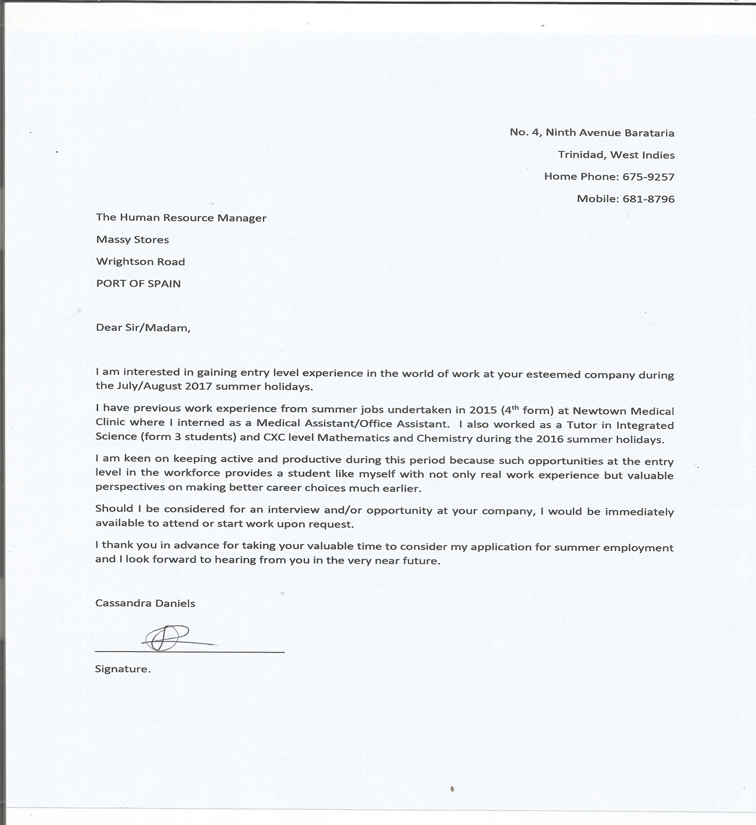

|  |  |  |  |  |  |  |
| --- | --- | --- | --- | --- | --- | --- |
| cassandra danielscassandradaniels145@gmail.com1-868-681-8796  |  | | --- | | Objective I am interested in a Summer Internship/job as a Cashier/Store Clerk/Office Assistant at Massy Stores | | Skills I have a working knowledge of Microsoft Excel Suite (Word, Excel, PowerPoint) | | |  | | --- | | Experiencesummer intern/ new town medical centreJuly – August 2015 Acted as a medical assistant, aided in lab work and acted as secretary for a few weeks. tutor/Pope’s science institueJuly – August 2016 Tutored Integrated Science at form 3 level  O’level Mathematics and Chemistry | | Education8 O’levels / 2016St. Francois Girls College Cape 1 – Complete exams  Chemistry, Biology, Pure Mathematics (awaiting results) | | Volunteer Experience or Leadership | |

Date: 21/06/2017

Too Whom It May Concern;

I hereby give permission to Cassandra Daniels to apply for vacation employment at your organization. I can be reached at the numbers below:

- 782- 1495 (mobile)

- 675- 9257 (landline Home)

- 625-7288 Ext 25056 (work)

I have authorized Cassandra to send the same without my handwritten signature, having knowledge of the aforementioned.

Maitland R. Daniels

Father.

